Skin Cancer Classifier

FYP-Propsl-Tmplt-03

FYP Proposal Number

CS-FYP-2015-001

Date of Submission

24-March-2017

Ibad Ur Razzaq Siddiqui / BSCS/F14/0110

Muhammad Kamil Amin / BSCS/F14/0104

Jawwad Ansari / BSCS/F14/0129

Supervisor

Muhammad Adeel Mannan



Department of Computing

Faculty of Engineering & Science

**Hamdard University**

**1.0- Introduction**

**1.1- Problem Statement**

On recent research, it was discovered that dermatologist can detect 65% accuracy on skin cancer diseases. It should be improved as because some dermatologist might detect cancer but it might not exist in the future detection.

**1.2 Motivation**

Our motivation was the recent news made by the Stanford University’s candidate on their discovery of detecting skin cancer by using deep neural networks [1]. It was concluded that Artificial Intelligence can detect with an accuracy of more than 80% compared to an experienced dermatologists [1].

**1.3 FYP Objectives**

The objective is to provide solution to skin cancer diseases which is a challenging task. Using the CNN model, which show potential for general show potential for general and highly variable tasks across many fine-grained object categories**,** we can classify common cancers.

**1.4 Literature Review**

There are 5.4 million new cases of skin cancer in the every year [2]. One in five people, will be diagnosed with a cutaneous malignancy in their lifetime. Although melanomas represent fewer than 5% of all skin cancers in the United States, they account for approximately 75% of all skin-cancer-related deaths, and are responsible for over 10,000 deaths annually. Early detection is critical, as the estimated 5-year survival rate for melanoma drops from over 99% if detected in its earliest stages, to about 14% if detected in its latest stages [3]. We developed a computational method which may allow medical practitioners and patients to proactively track skin lesions and detect cancer earlier. By creating a novel disease taxonomy, and a disease-partitioning algorithm that maps individual diseases into training classes, we are able to build a deep learning system for automated dermatology [4].

**2.0 Project Scope**

Explain with the help of diagrams and text what is included in the project scope

Clearly mention what is included and what is excluded

This will be seen in your final defense (and report)

You may use following diagrams or any other modeling you know

Context Diagram (big Picture)

Use-case (Functionality)

Process Flow (BPMN v2)

**3.0 Methodology**

**3.1 Project Approach** (Waterfall/Agile)

Project approach to be followed is Waterfall.

**3.2 Team Role & responsibilities** (RACI matrix)

R = Responsible

A = Accountable

C = Consulted

I = Informed

Responsible, Accountable, Consulted, Informed

|  |  |  |  |  |
| --- | --- | --- | --- | --- |
| WBS | M. Kamil Amin | Ibad Ur R. Siddiqui | Jawwad Ansari | M. Adeel Mannan |
| Problem statement | R | A | I | C |
| Project Planning | R | R | I | A/C |
| Requirements | R | I | R | C |
| Design | I | I | R | C |
| Development | A/R | A/R | I | I |
| Testing | A/R | R | A/R | C |

**3.3 Requirement Development**

Elicitation of requirements

Analysis of requirements

Software requirements Specification (SRS)

Requirement Validation

**3.4 Architect / Design**

**3.5 Development / Construction**

We will develop web-based project using HTML5, CSS3, and React.JS for User Interface.

For back-end processing of this project, we will be using python, Tensor flow, Theano, OpenCV, Keras, Inception Architecture v-3, CNN model (convolutional Neural Network), ImageNET as a database for training the deep learning model.

**3.6 Application (or Project) Testing**

Following testing methods will be applied to the project:

* Black Box Testing
* White Box Testing

**4.0 Project Planning**

**4.1 Gantt Chart**

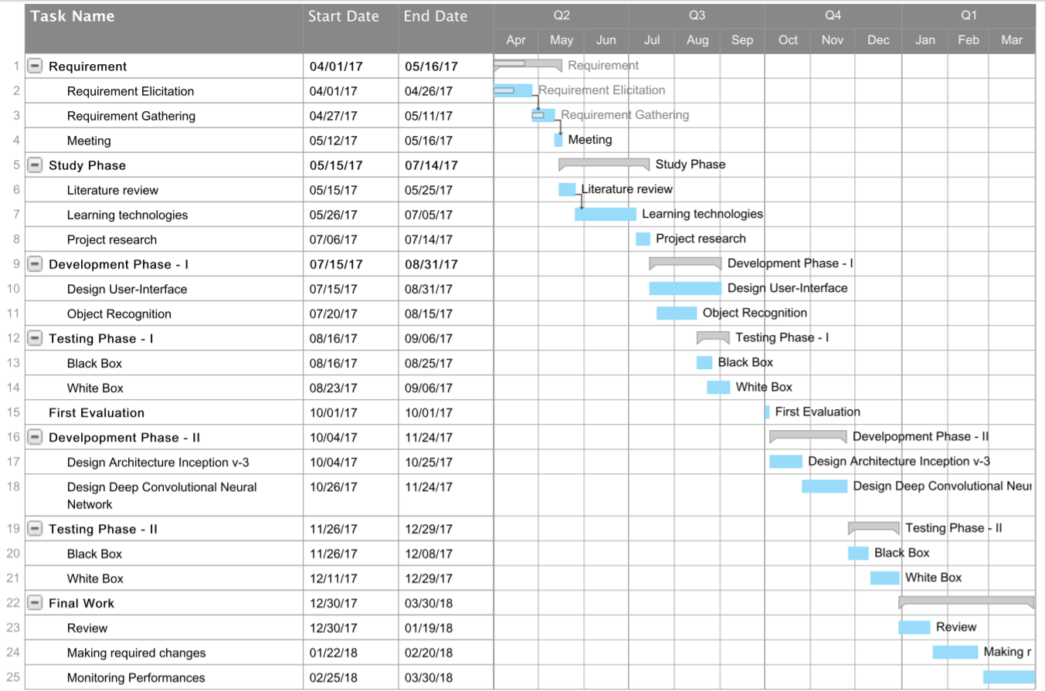

**4.2 Mention following *milestones* in your Plan**

* **At the end of 7thsemester (on first evaluation):**
  + Application having: Interfaces, upload, visual object recognition.
* **At the end of 8thsemester (on final evaluation):**
  + Completed Integration and tested delivery.

**5.0 Project Requirements**

**5.1 Software tools requirements**

* Python – Programming language.
* Flask, Django – Libraries for python for Web-Development.
* HTML, CSS3, React.JS – For Web-Development
* Anaconda – for Large-Scale data processing and scientific computing.
* TensorFlow – Open Source library for machine Learning.
* ImageNet – Image database used for visual object recognition.
* Open-CV – for computational efficiency and real-time application.
* Theano – define, optimize, and evaluate multi-dimensional arrays efficiently.
* Keras – Deep learning library for Theano and TensorFlow.

**5.2 Hardware requirements**

* GeForce GTX 1080 – For GPU processing.
* Higher Performance System or Server required or i7-5900x for testing CNN results of skin cancer.
* Laptops: HP Z-Book i7-5th and HP Pro-Book i5-2th.

**6.0 Budget/Costing**

* 1. **Mention the budgeting cost of each item -** required for the this project
* GeForce GTX 1080
  + Costing: $ 549.00
* Laptop HP Z-Book i7-5th 
  + Cost: $ 700.00
* Laptop HP Pro-Book i5-2th
  + Cost: $ 300.00
* Labor work:
  + Cost: $ 500.00

**6.2 Total Budgeted Cost -** of the Project

The total budgeted cost for the project is estimated up to be **$ 2,050.00**

**7.0 Project Deliverables**

Following are the **project deliverables**:

* Requirements documentation
* Design documents.
* Running project Application.

**8.0 Reference**

[1] A. Esteva1, B. Kuprel, R. A. Novoa, J. Ko, H. M. B. & S. T. Andre Esteva1*, Brett Kuprel1*, Roberto A. Novoa2,3, Justin Ko2, Susan M. Swetter2,4, and S. M. S. H. M. Blau5, “Dermatologist-level classification of skin cancer with deep neural networks,” *Nat. 2017*, 2017.

[2] WHO, “Ultraviolet radiation and the INTERSUN Programme.” [Online]. Available: http://www.who.int/uv/faq/skincancer/en/index1.html.

[3] N. Codella *et al.*, “Deep Learning Ensembles for Melanoma Recognition in Dermoscopy Images,” *arXiv cs.CV*, vol. 10, no. 4, p. 4662, 2016.

[4] Hao Chang, “Skin cancer reorganization and classification with deep neural network,” 2017. [Online]. Available: https://arxiv.org/ftp/arxiv/papers/1703/1703.00534.pdf. [Accessed: 01-Jan-2017].